**PSQL Commands**

Windows PowerShell

Copyright (C) Microsoft Corporation. All rights reserved.

PS C:\Users> psql -U postgres

postgres=# create database bank;

CREATE DATABASE

postgres=# \c bank;

bank=# create table CUSTOMER(Customer_ID varchar(10) primary key, First_Name varchar(20) NOT NULL, Last_Name varchar(20), PIN int NOT NULL, District varchar(10), State varchar(10), Phone_number int, DOB date NOT NULL, Email varchar(25));

CREATE TABLE

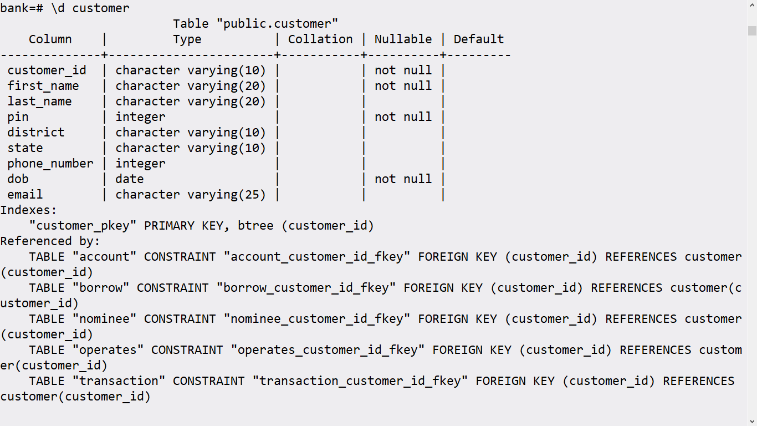

create table TRANSACTION(tr_id varchar(25) primary key,customer_id varchar(10), tr_type varchar(20) NOT NULL, date date not null, time interval not null, method varchar(20) not null, tr_status varchar(20) not null, foreign key(customer_id) references customer(customer_id));

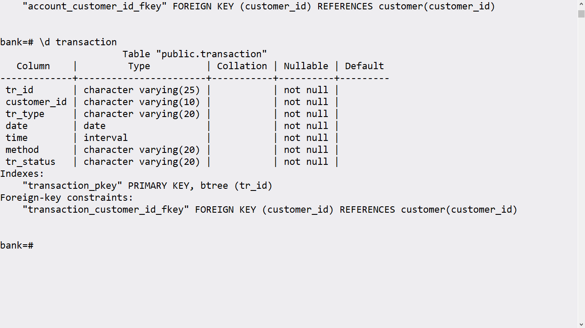

bank=# create table nominee(name varchar(25), customer_id varchar(10), address varchar(50), phone_number int, foreign key(customer_id) references customer(customer_id));

CREATE TABLE

bank=# alter table nominee drop name;

ALTER TABLE

bank=# alter table nominee add name varchar(25) primary key;

ALTER TABLE

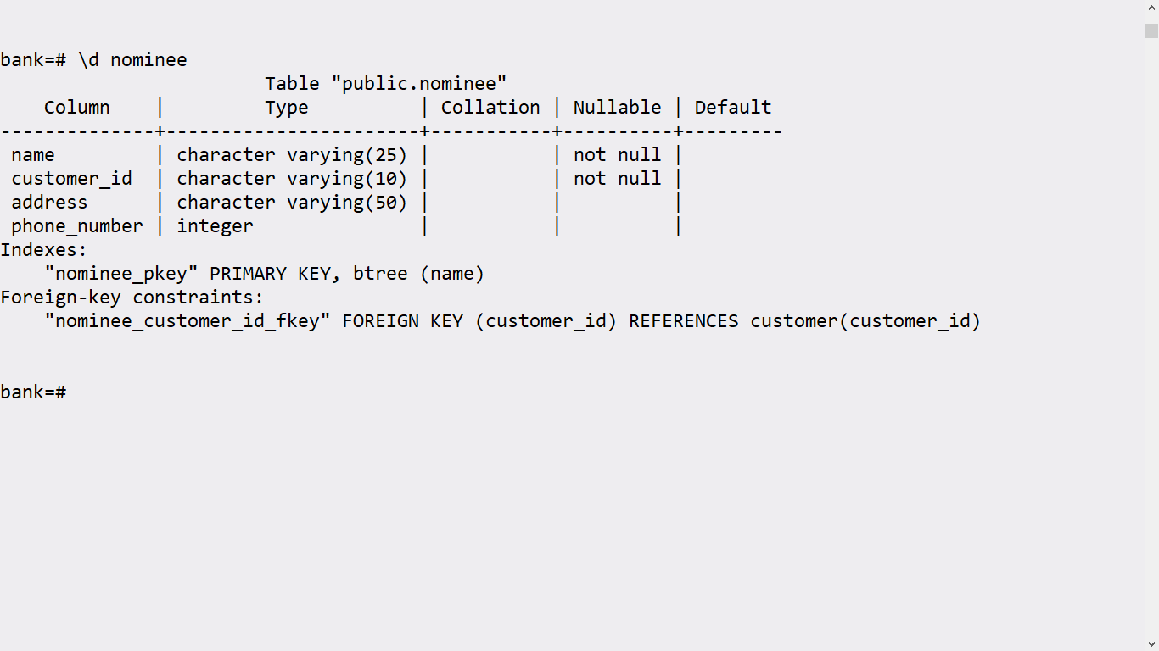

bank=# create table atm(atm_id varchar(10) primary key, bank_id varchar(10) not null, cash_limit int, location varchar(20), foreign key(bank_id) references bank(bank_id));

CREATE TABLE

bank=# \d atm

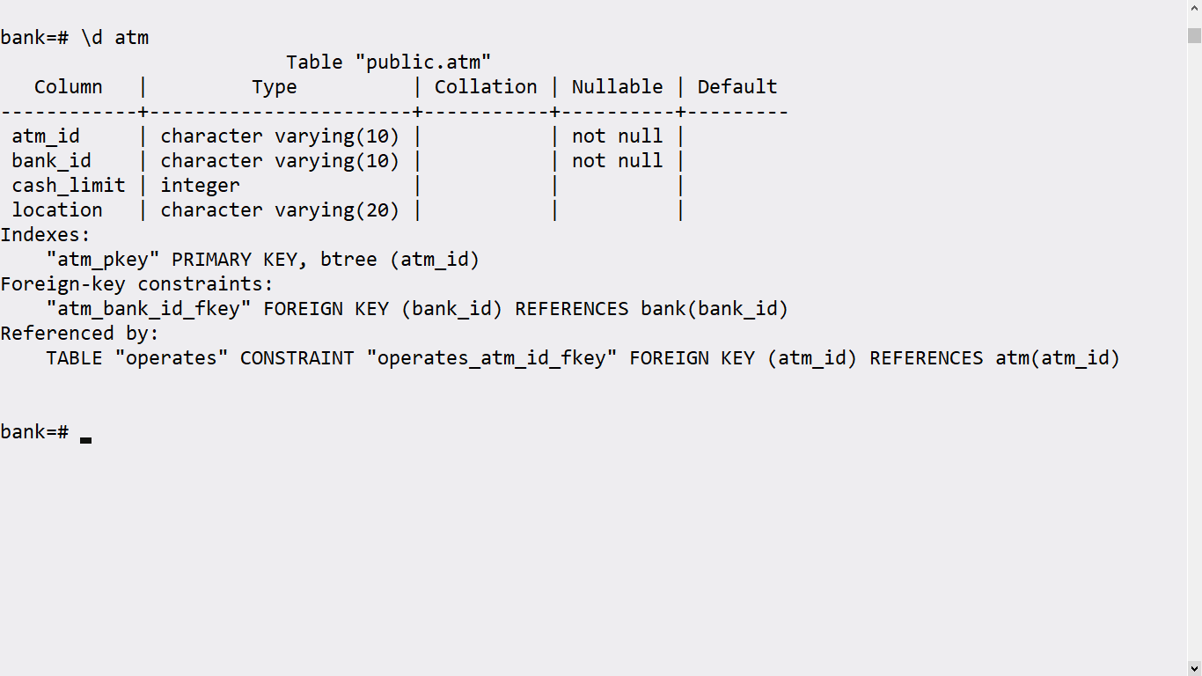

bank=# create table Operates (atm_id varchar(10) , customer_id varchar(10) not null, foreign key(atm_id) references atm(atm_id), foreign key(customer_id) references customer(customer_id));

CREATE TABLE

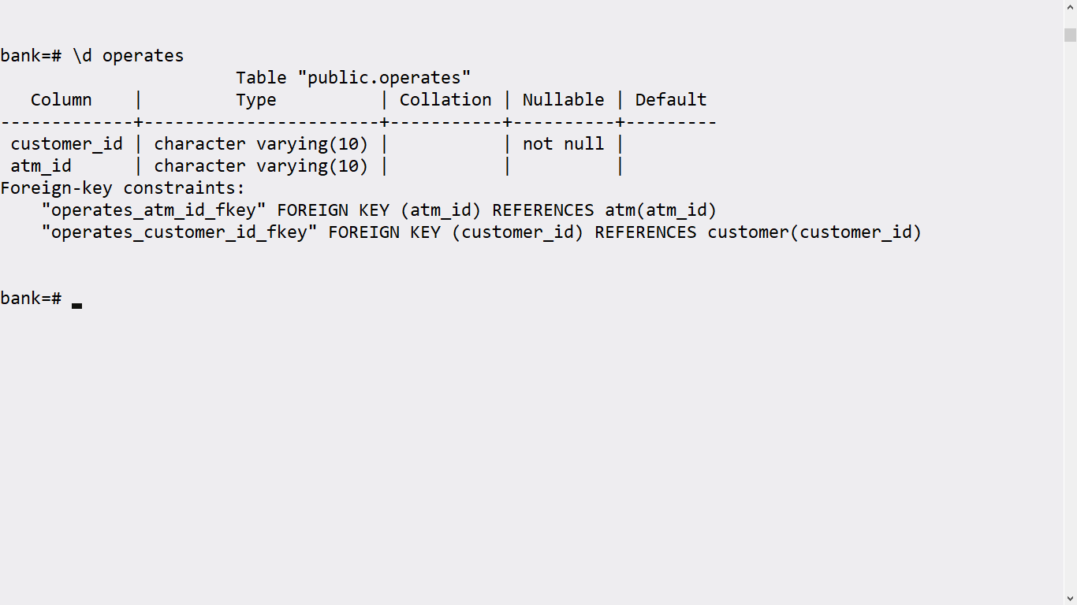

bank=# create table account(account_number int primary key, customer_id varchar(10) not null ,ifsc varchar(10) not null, password varchar(20), account_type varchar(10), balance int, foreign key(customer_id) references customer(customer_id), foreign key(ifsc) references branch(ifsc));

CREATE TABLE

bank=# \d account

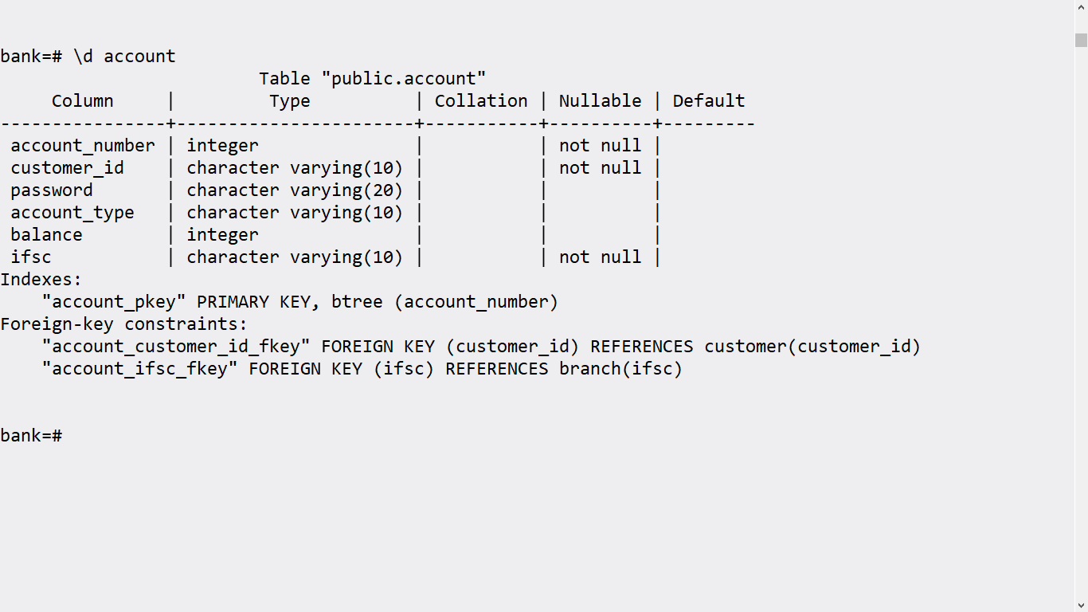

bank=# create table loan(loan_number varchar(20) primary key, loan_amount int);

CREATE TABLE

bank=# create table borrow(customer_id varchar(10), loan_number varchar(20), foreign key(customer_id) references customer(customer_id), foreign key(loan_number) references loan(loan_number));

CREATE TABLE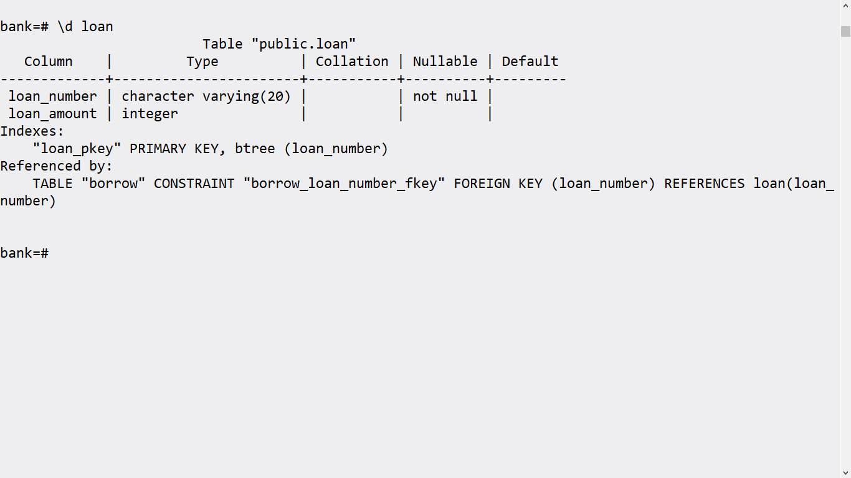

bank=# create table bank(bank_id varchar(10) primary key, Bank_name varchar(25), bank_address varchar(50));

CREATE TABLE

bank=# \d bank

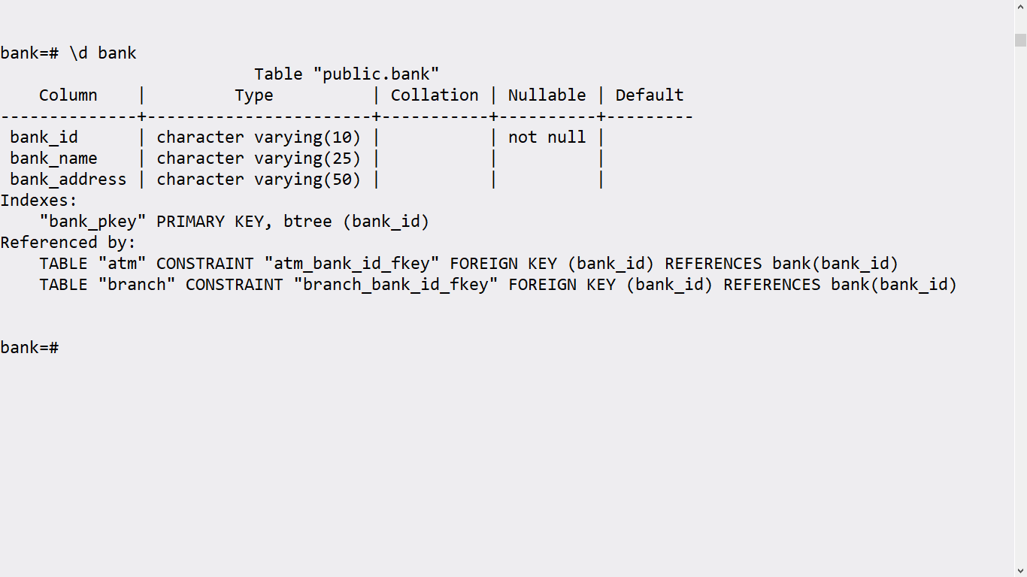

bank=# create table branch(ifsc varchar(10), branch_name varchar(25), pin varchar(6), state varchar(20),country varchar(10), phone_number int, bank_id varchar(10) not null, foreign key(bank_id) references bank(bank_id));

CREATE TABLE

bank=# alter table branch drop ifsc;

ALTER TABLE

bank=# alter table branch add ifsc varchar(10) primary key;

ALTER TABLE

bank=# \d branch

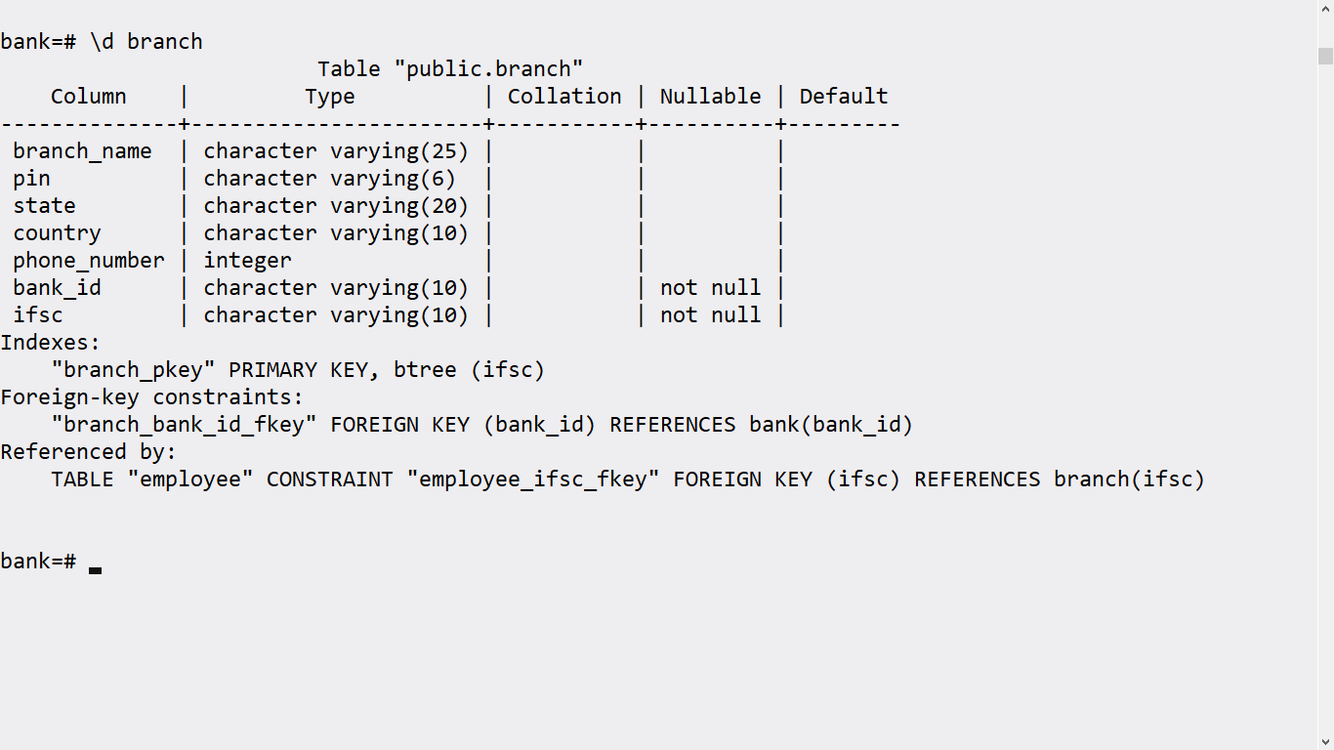

bank=# create table employee(emp_id varchar(10) primary key, name varchar(25),dob date not null, address varchar(50), email varchar(25), phone_number int,supervisor_id varchar(10) not null, ifsc varchar(10) not null, foreign key(ifsc) references branch(ifsc), foreign key(supervisor_id) references employee(emp_id));

CREATE TABLE

bank=# \d employee

